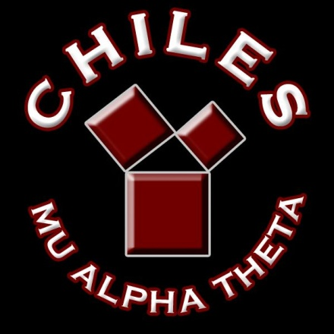**CHILES MU ALPHA THETA**

**2020-2021**

**COMPETITION SCHEDULE**

**TBA FSU Math Competition**

**TBA Rickards Invitational**

**December 12 Chiles Mini Mu**

**January 16 Buchholz Statewide**

**January 30 Panama City Arnold Regional**

**February 13 Lincoln Regional**

**February 26-27 Naples Dunbar Statewide**

**TBA NWFSC Math Bowl**

**March 6 Rickards Regional**

**April 15-18 State Convention @ Orlando**

**Rosen Plaza Hotel**

**July 10-16 National Convention @**

**Washington DC**